Q1：
LoginServlet.java
1.
change
"<input type=\"submit\" value=\"Sign in\" />\n"
to
"<input type=\"submit\" value=\"Sign in\" onclick=\"handleLogin()\" />\n"

2.
add
"document.querySelector(\"input[type=submit]\").addEventListener(\"click\", " +
"handleLogin);\n" +
into
"<script>"
...
"</script>"

3.
change
"<form action=\"login\" method=\"POST\">\n"
to
"<form action=\"login\" method=\"POST\" onsubmit=\"handleLogin()\">\n"

Q2:
MainServlet.java
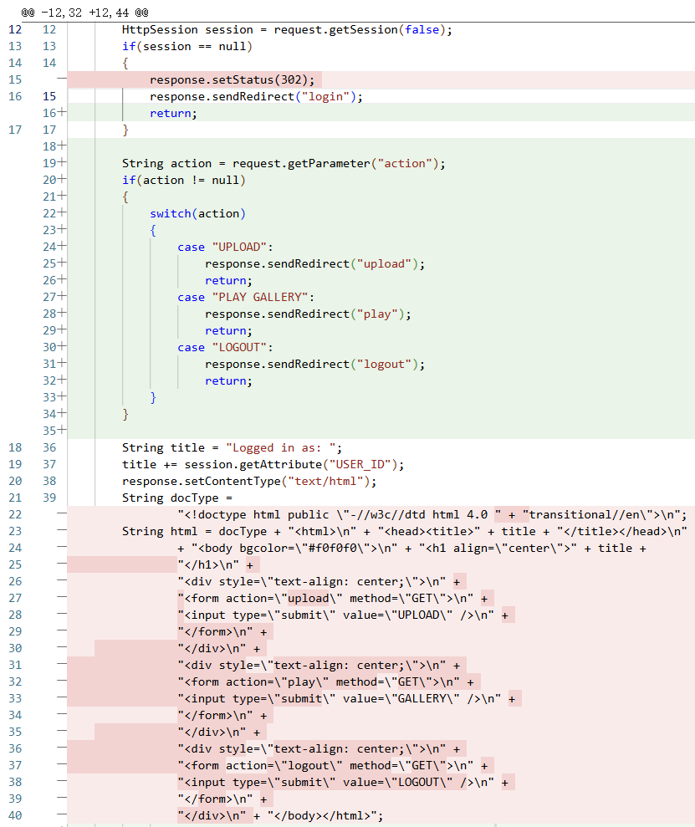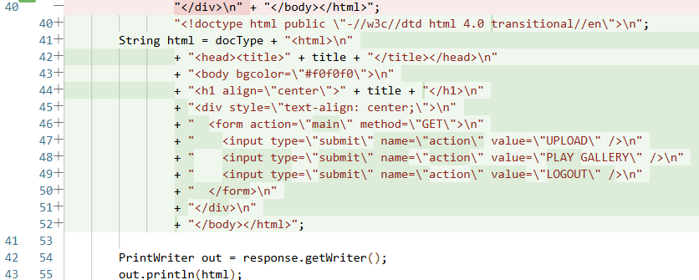
In the original implementation, navigation is done through three separate forms. Each form has its own action attribute, so when the user clicks a button, the browser sends a single HTTP request directly to the corresponding servlet.
In the revised implementation, there is only one form with multiple submit buttons. No matter which button is pressed, the request is first sent to MainServlet with an extra parameter action. MainServlet reads it and then redirects to the corresponding servlet, which requires one more HTTP round-trip.
Original:
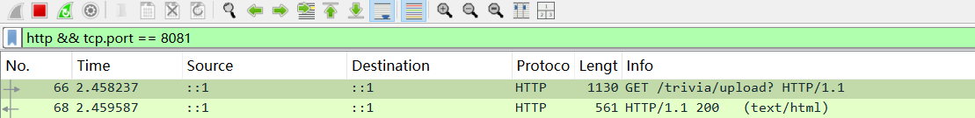
One request directly to /upload and a 200 OK response.
Revised:
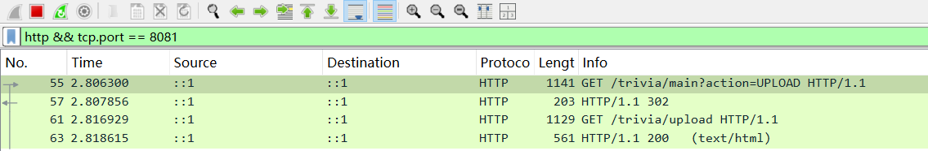
First request to /main?action=UPLOAD, server responds with 302 Found, then the browser follows the redirect and

Q3

a.
LoginServlet.java
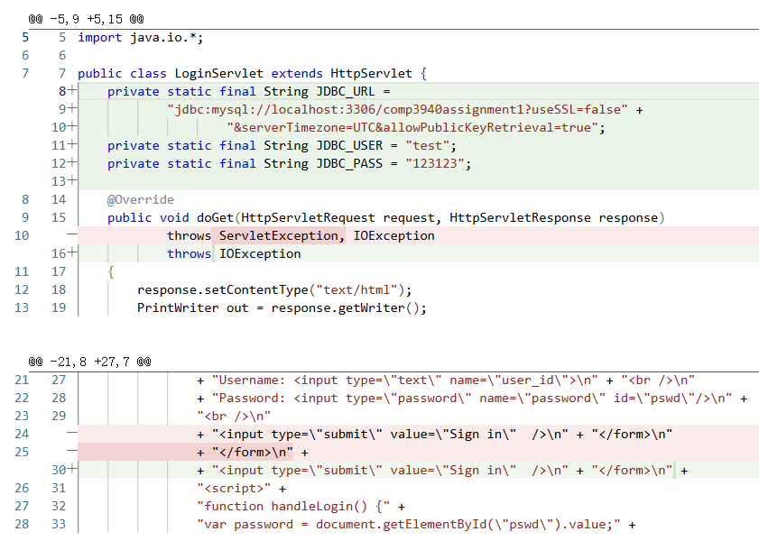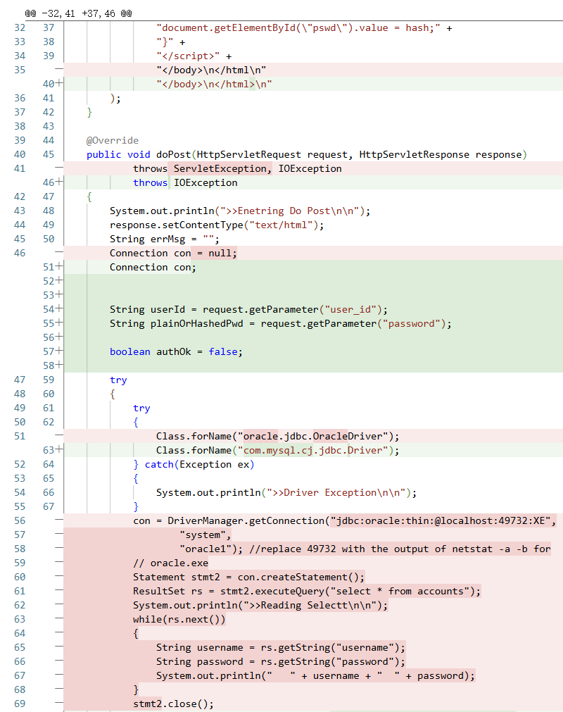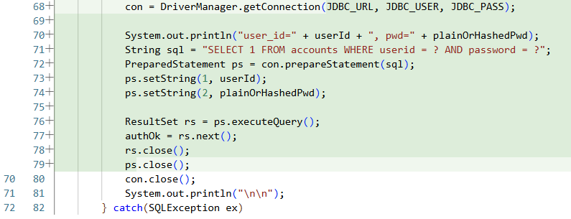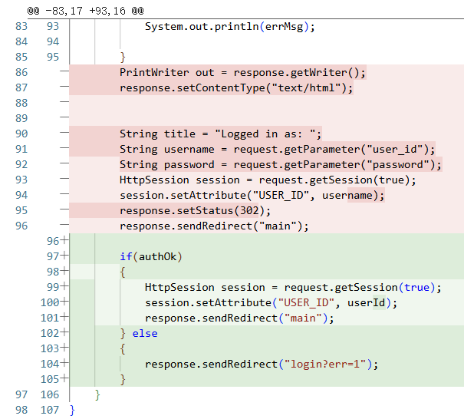

b.
PlayServlet.java
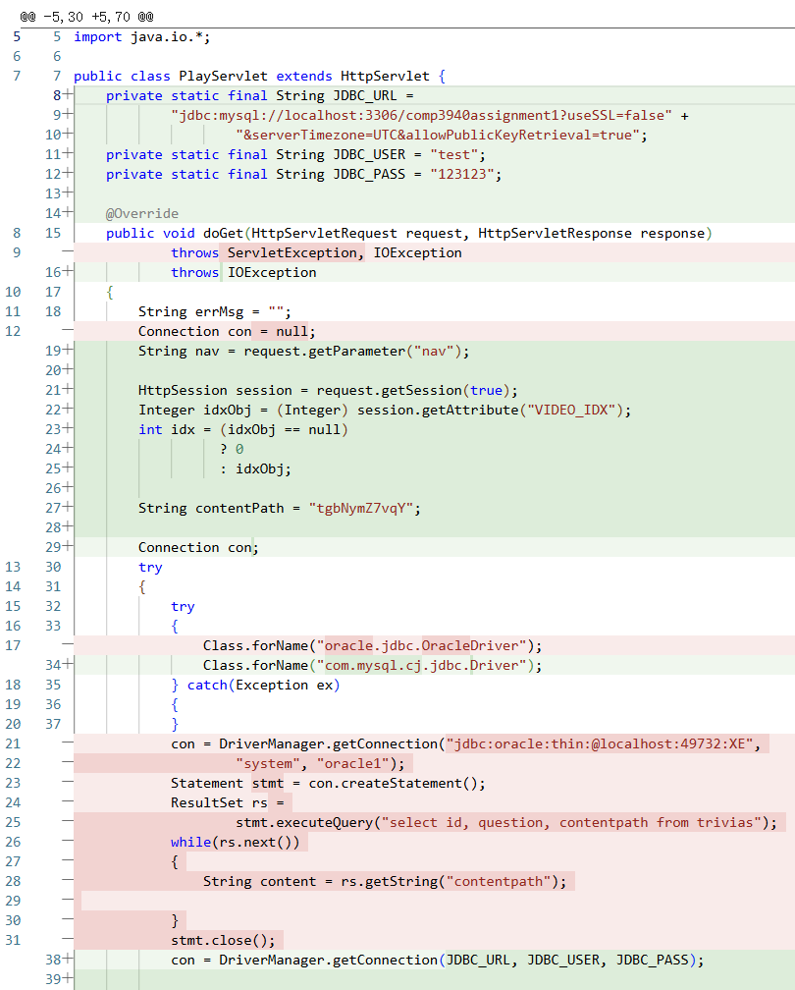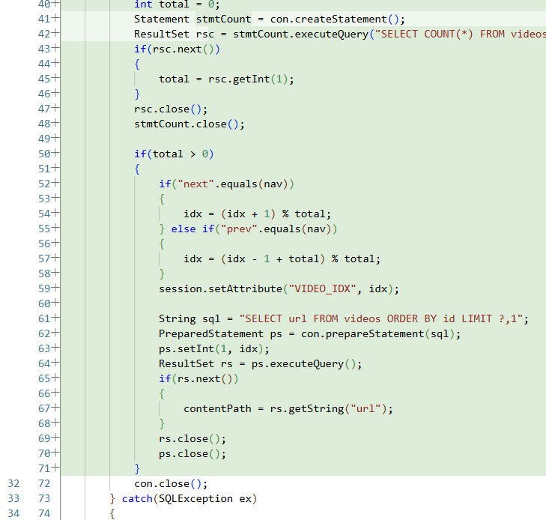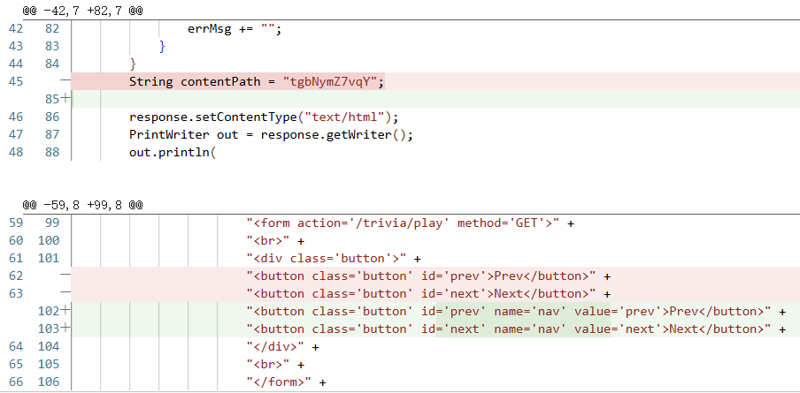

Q4
index.html
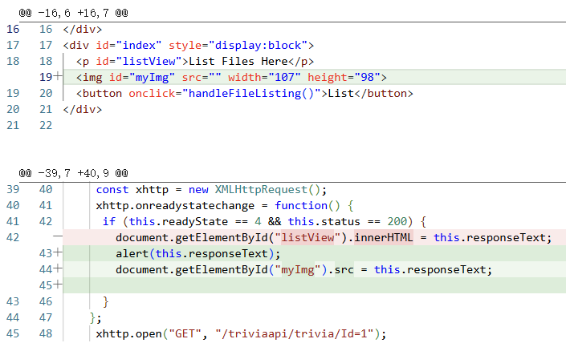

Trivia.java
